**FUNDAMENTALS OF DATABASES – WEEK 3 – ACTIVITY 1**

Supply/perform what is asking in the following statements. Attach or put a screenshot for each number to support your answers.

1. Search a website or install a free software (for those who have laptop) which can be used as example of different types of interfaces for database or data management in the software/system.
2. Capture or make a screenshot for each types of interface given below and briefly explain its importance or benefits to the users.
   1. Menu-Based Interface
   2. Forms-Based Interface
   3. Graphical User Interface
   4. Natural language Interface
   5. Speech Input and Output
   6. Interfaces for DBA

1. 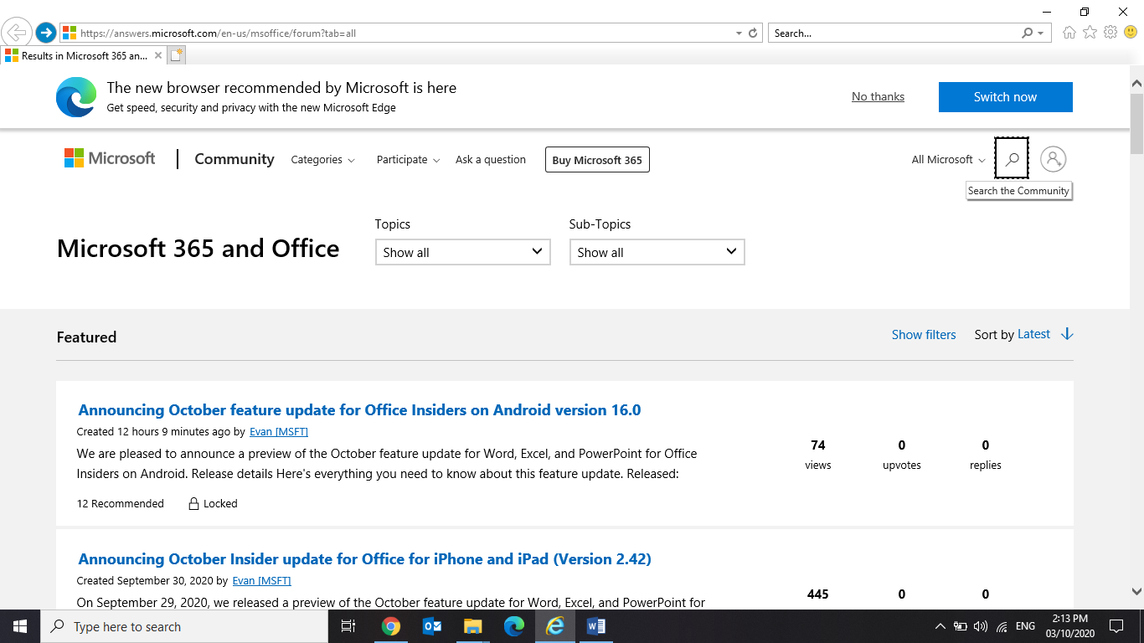

2.

1. Menu – Based Interface

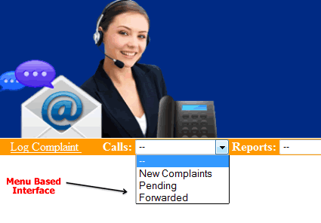

 Web based interface are the best examples of menu based interfaces. These types of interfaces provide a list based options to users. Any query can be run by just picking options from menu that is displayed on screen.

1. 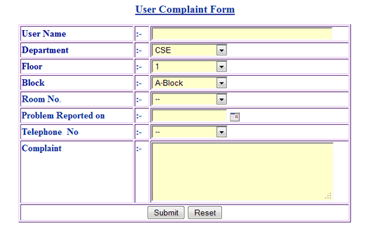Forms – Based Interface

In this type of interfaces users are allowed to fill out form entries to insert new data or they have to fill certain data so that on that basis data can be retrieved from database. Registration forms, Feedback forms, complaint forms, search forms are best example of such type of interfaces.

1. Graphical User Interface

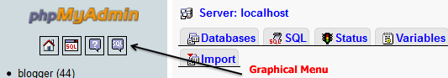

This interface represents database schema in graphical format to users. This consists of both menu s and graphics. Queries can be run by clicking on appropriate pictures /icons. For the selection purpose pointing device is used that can be either mouse or touch screen based.

1. Natural Language Interface

http://1.bp.blogspot.com/-mONFl8IFVes/UYn2CTBXkYI/AAAAAAAAAtk/M_KaXFvBcfg/s1600/Untitled-7.gif

In this type of interface DBMS provides local language support. The user generates his queries in his own language and results that match are displayed or respective action is taken on that query.given below image gives option of language support in which you can switch interface.

1. Speech Input and Output



In this type of interface user does not have to type he provides voice based queries and voice based or graphical results are obtained by him. Voice Recognition System is best example of this.

1. Interfaces for DBA

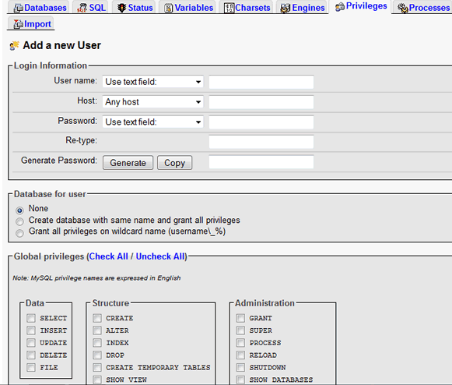

This interface is used by the database administrator to create databases, Users, to set system parameters for changing database schema etc. Fig. given below shows admin menu where DBA is can create new user and can assign privileges to him.